Ven-Powery Help Document

Date : 22 Sep. 18

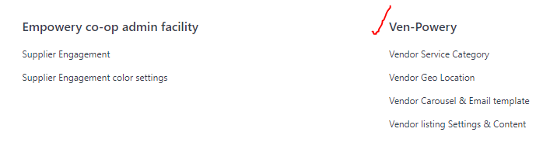

App Doctype Explanation

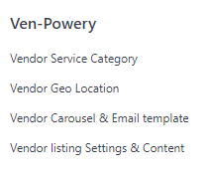

1. ***Vendor Service Category*** contains records for various service category provided by the supplier. For example refer below,

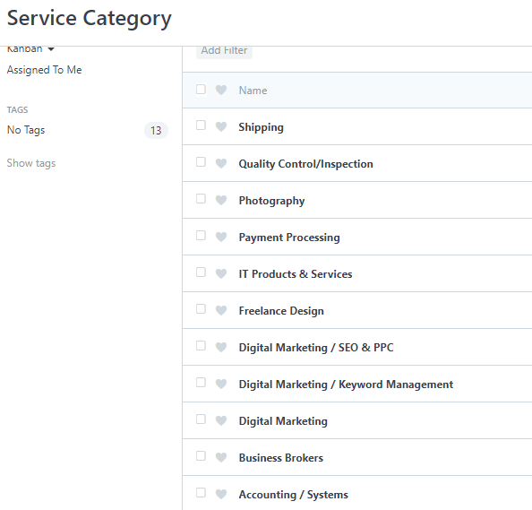

1. ***Vendor Geo Location*** : To create Vendor Geo Location list , which in turn will help to restrict the search results on the supplier offer listing page.

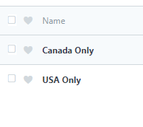

1. ***Vendor Carousel and Email Template*** : To Setup the carousel on Ven-powery page and Email Template ( for the emails that will be sent when visitor fills the form and clicks on ***“Request Information”*** button.

The carousel banner image size should be => 537px X 279px.

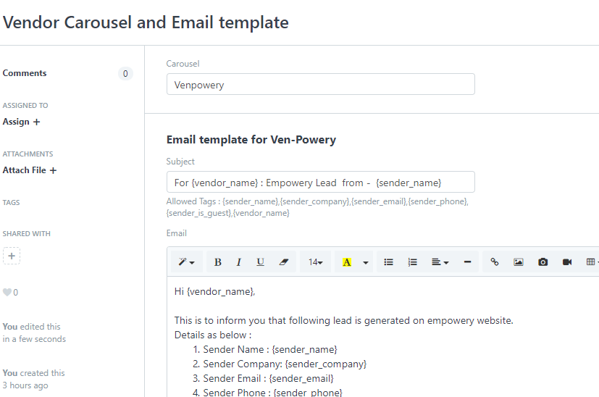

1. ***Vendor Listing Settings and Content :***

*Supplier type belonging to “Affiliate Partner or Supplier Partner are only listed on the page under respective group.*

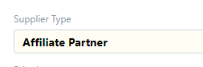 ***or*** 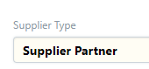

1. ***Vendor Listing Settings Section***

. 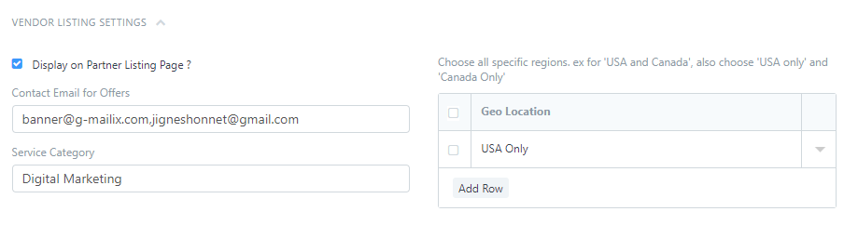

**Fields :**

**Display on Partner Listing Page ? :**  if checked (true) then it will display the vendor on the listing page, provided the *Supplier Type* is either *Supplier Partner* or *Affiliate Partner*

*The Field is set permission level 1 , so it will be visible to only those roles which will be having permission level 1 or more for supplier doctype. At present, it is made visible to System Manager Role.*

**Contact Email for Offer** : Multiple Comma separated valid email address will receive email notification for the leads generated for them from the empowery portal listing.

**Geo Location:** Choose all specific region. Ex for USA and Canada, put USA Only and Canada Only

It basically helps to restricts the search results based on GEO Location filter.

**Service Category:** Supplier can be mapped to single Service Category

1. ***Vendor Listing Content***

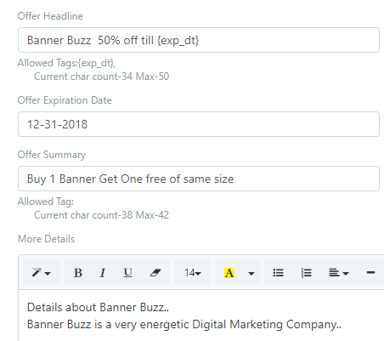

**Offer Headline :** 2 line limit of approximate 41-43 characters (bold font) per line. Tags allowed {exp_dt}

**Offer Expiration Date:**  Offer expiry date

**Offer Summary:** 2 line limits of approximate 50 characters (reg font) per line, Allowed Tags

**More Details**: Link to static information , dropdown (window shade) that is hidden by CSS in the page. It will be shown only to the members of the empowery and will restricted for the visitors.

**Disclaimer:**  Disclaimer text content for the offer.

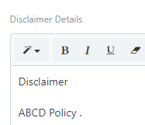

**Venpowery Offer Expiry Notification**

Venpowery Offer Expiry Alert , is set in Email Alert , It will fire an email 7 days before an offer is about to expire. The Email alert will be send to the support team informing about the vendor and it’s offer expiry date.

[**https://www.empowery.com/desk#Form/Email%20Alert/Supplier%20Listing%20Offer%20is%20about%20to%20Expire**](https://www.empowery.com/desk#Form/Email%20Alert/Supplier%20Listing%20Offer%20is%20about%20to%20Expire)

**Supplier Offer Listing Page**

[**https://empowery.com/vendor_offer_list.html**](https://empowery.com/vendor_offer_list.html)

